1. Download Jenkins from [Generic Java package (.war)](https://get.jenkins.io/war-stable/2.426.3/jenkins.war) LTS
2. After downloading go to command line from the location where the war file is present and enter command: java -jar jenkins.war

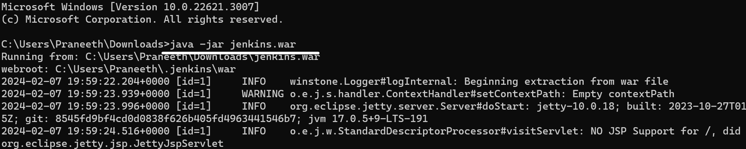

1. It will give password,

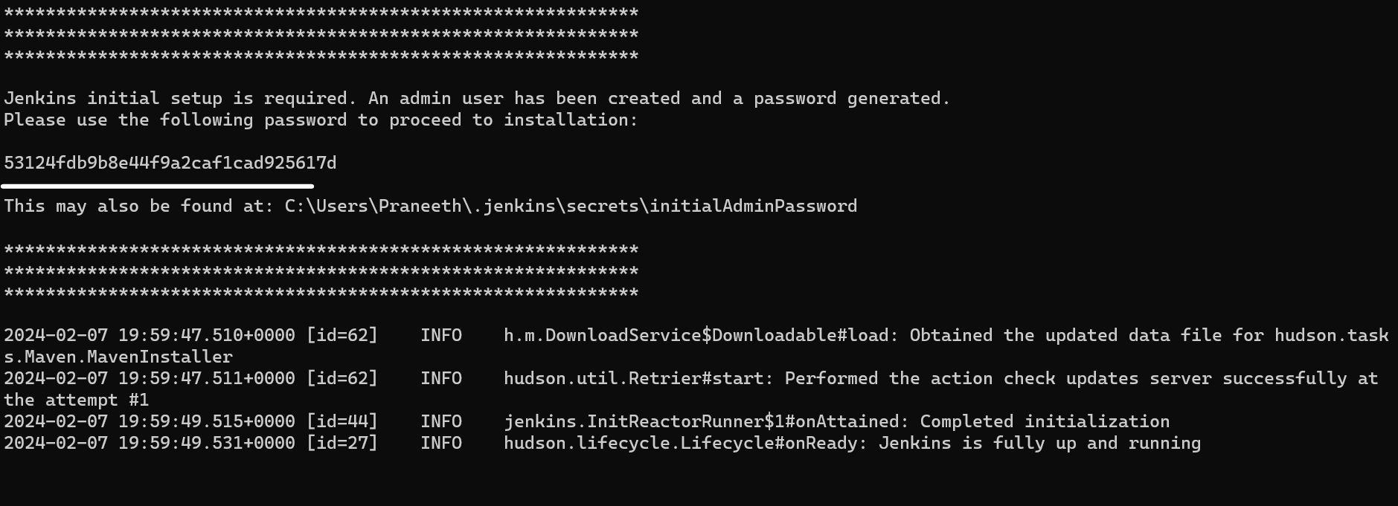

1. Go to 8080 port, its default one and enter the password there

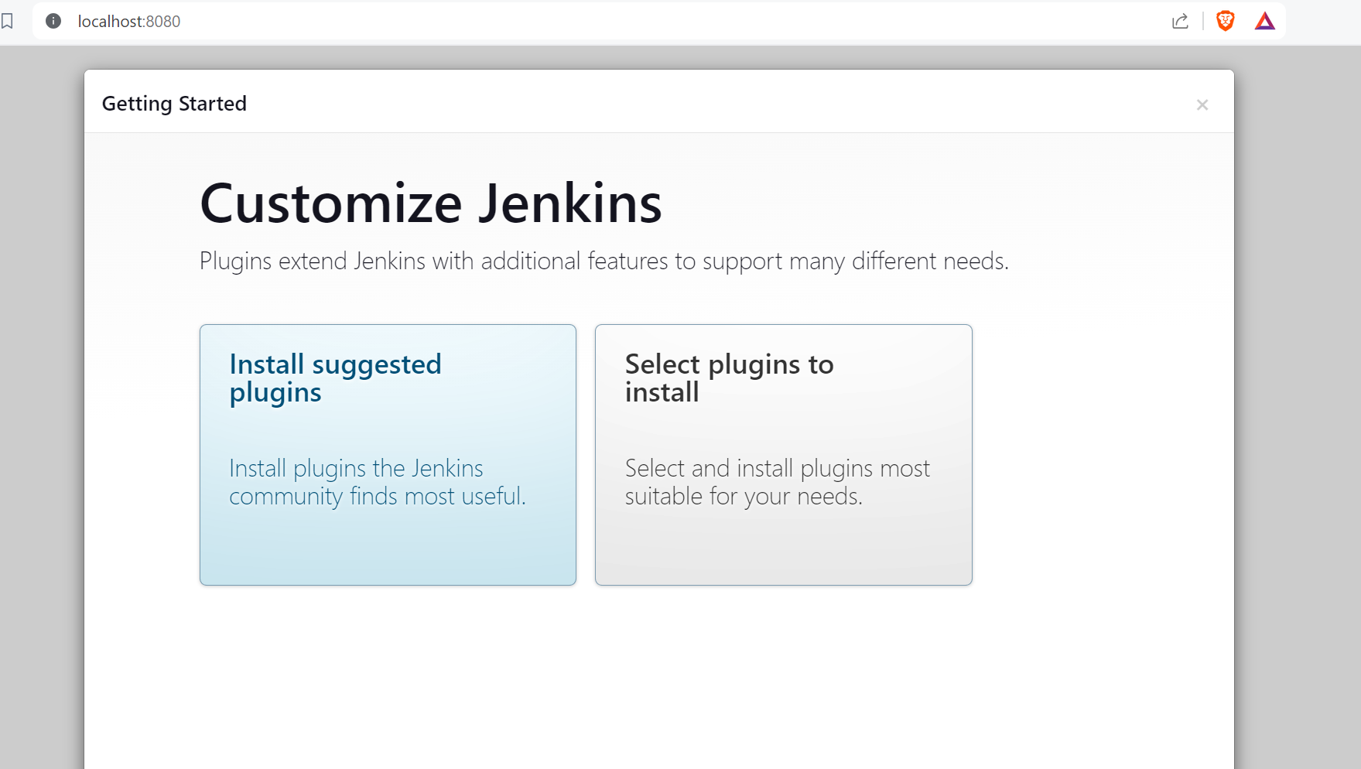

1. Install suggested plugins

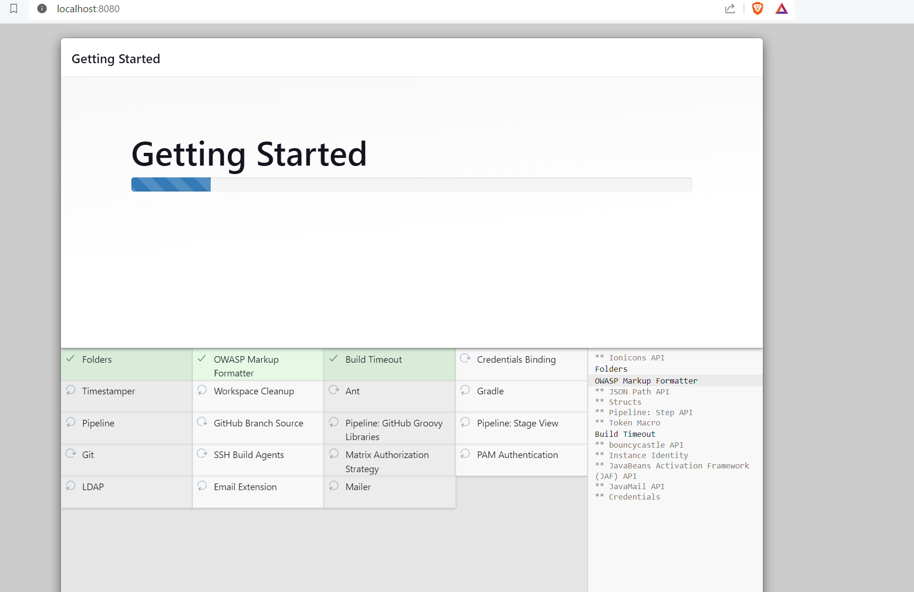

1. After installing plugins create first admin user, save and continue

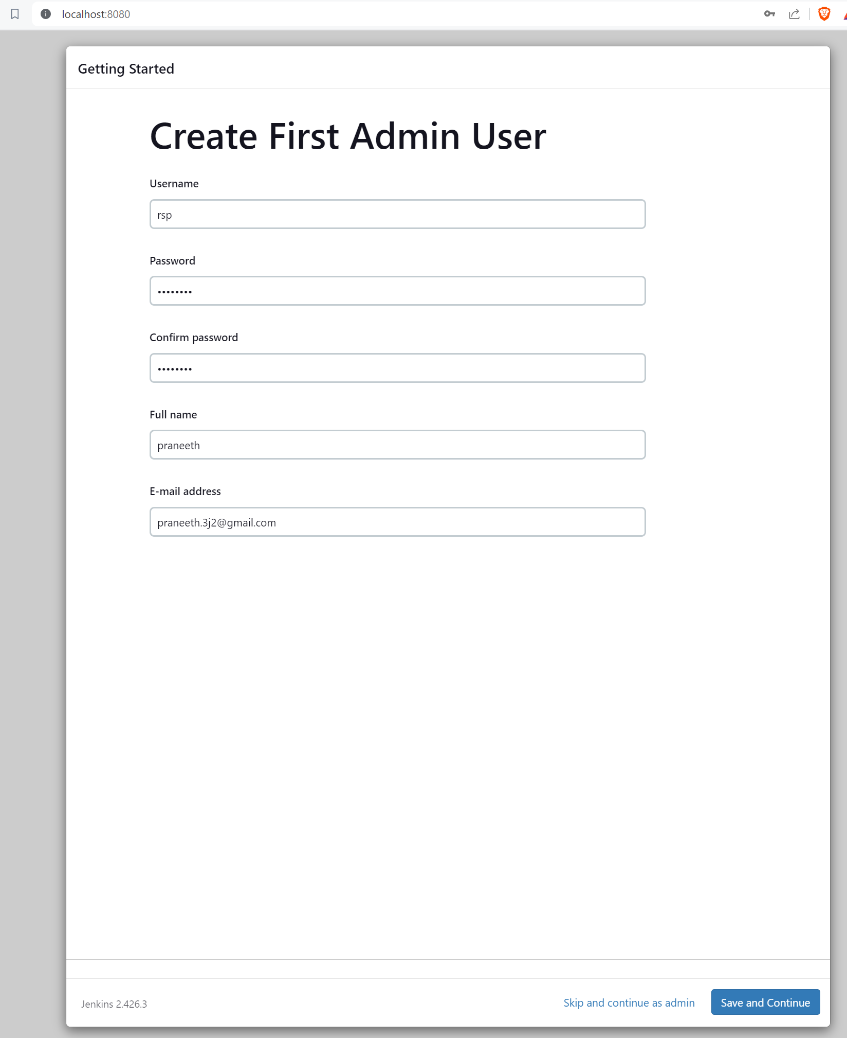

1. Save jenkins URL in next step, Save and Finish.

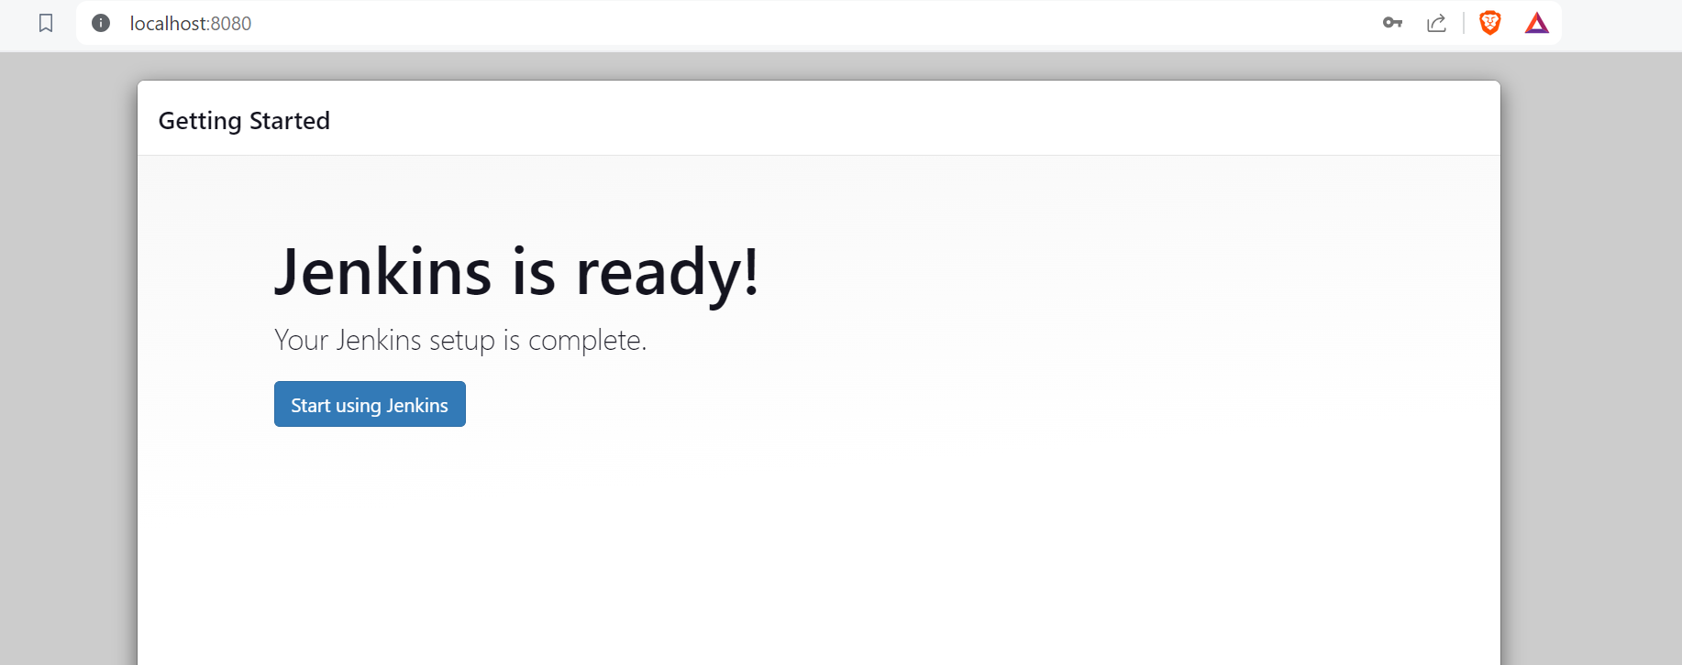

1. Make you springboot app ready, push to git and create a new job in jenkins

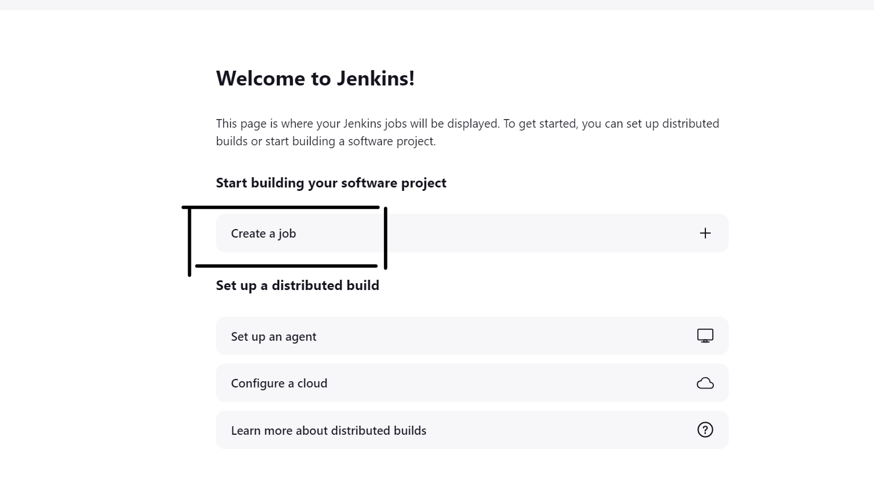

1. Next page enter name, select freestyle project and proceed, configure->general page will be displayed.
2. Next step select github project, and enter git repo url.
3. Add credentials in source code management. Creds are jenkins creds

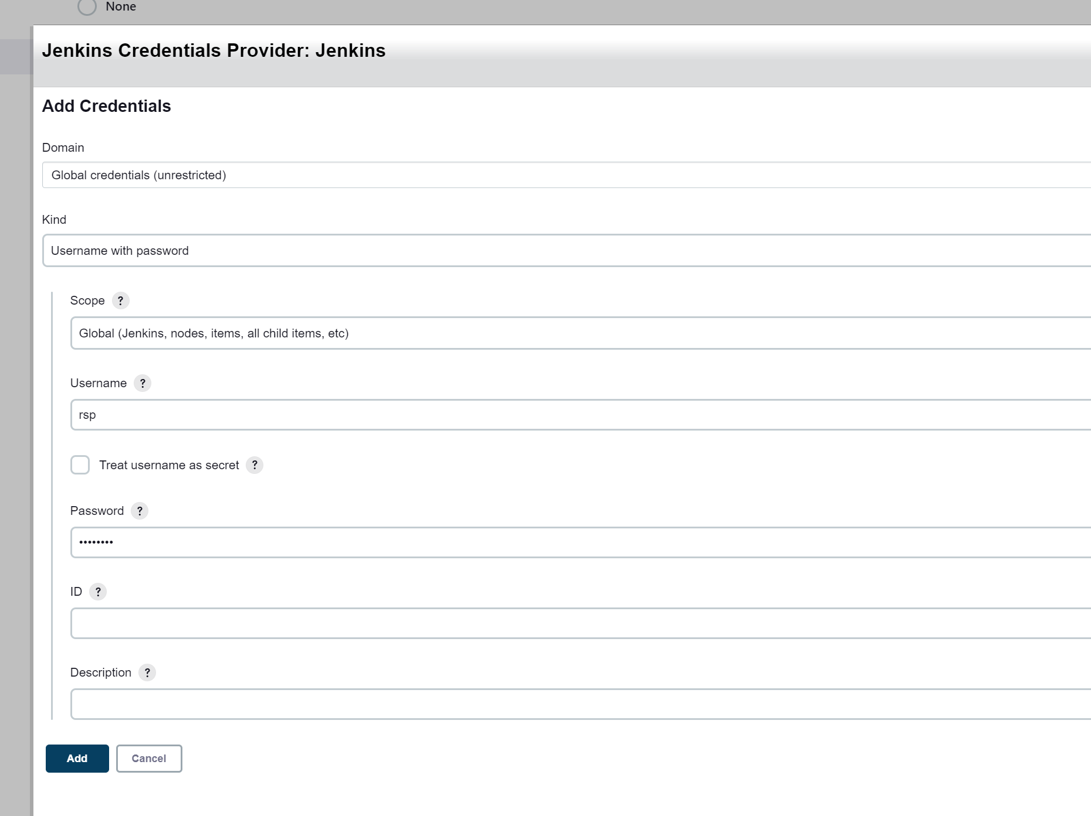

1. Build trigger, duration when to trigger build

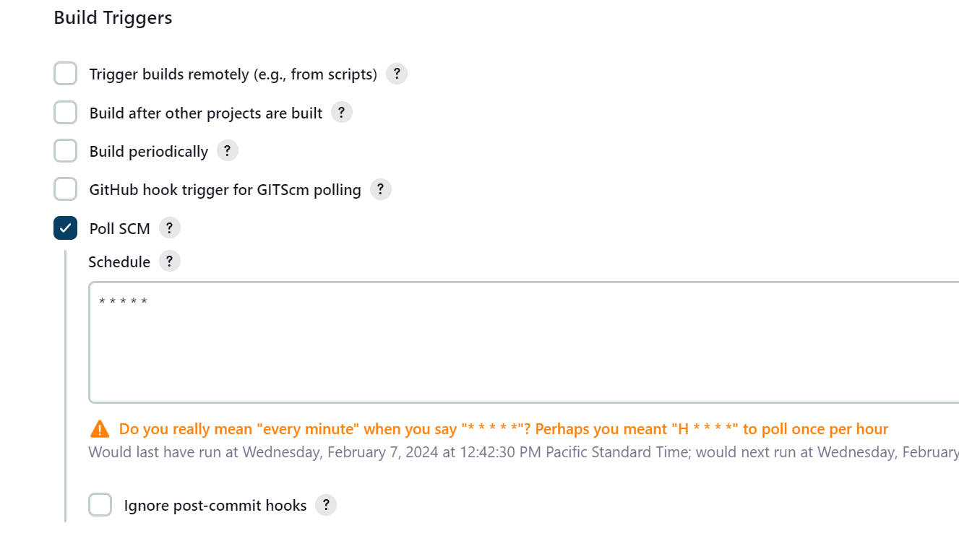

1. Set Build Steps and Post-Build steps, and click Apply

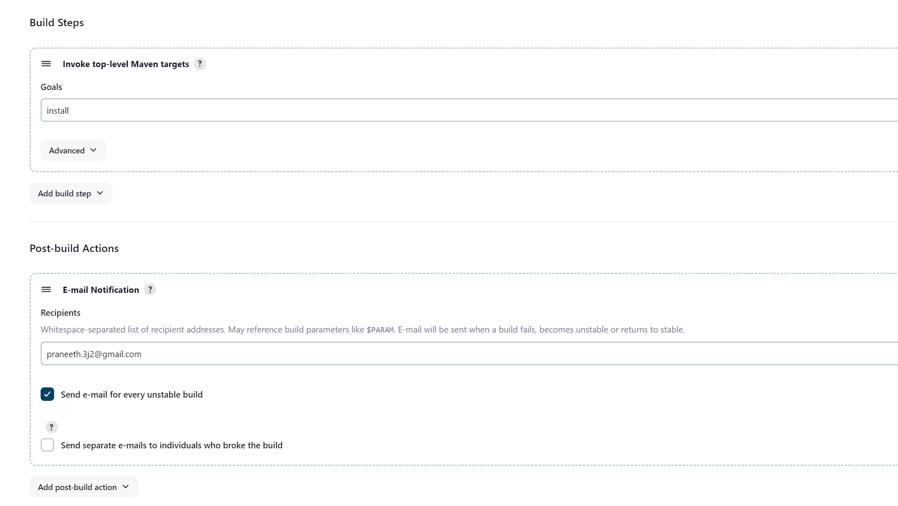

1. We can see in dahsboard

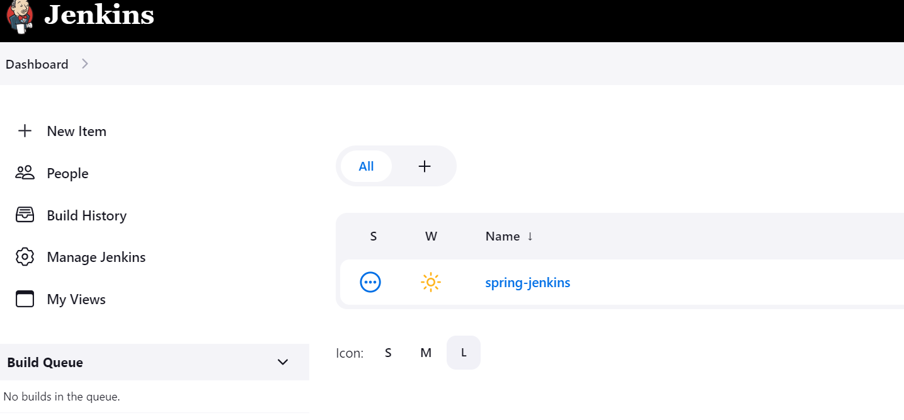

1. Have to set maven and mail configurations in Global settings

Maven: Install maven , set env variable.

Mail: set smtp server, mail port, email, password(not mail password, one set in settings)

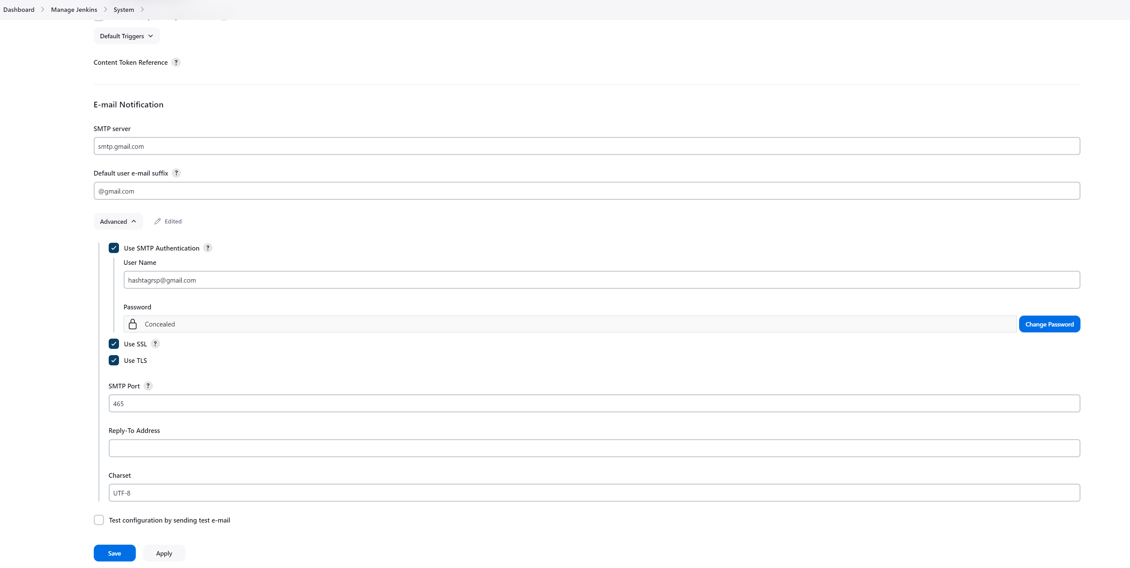

Install maven in local and give address, define in env variables PATH and create new variable as MAVEN_HOME as well.

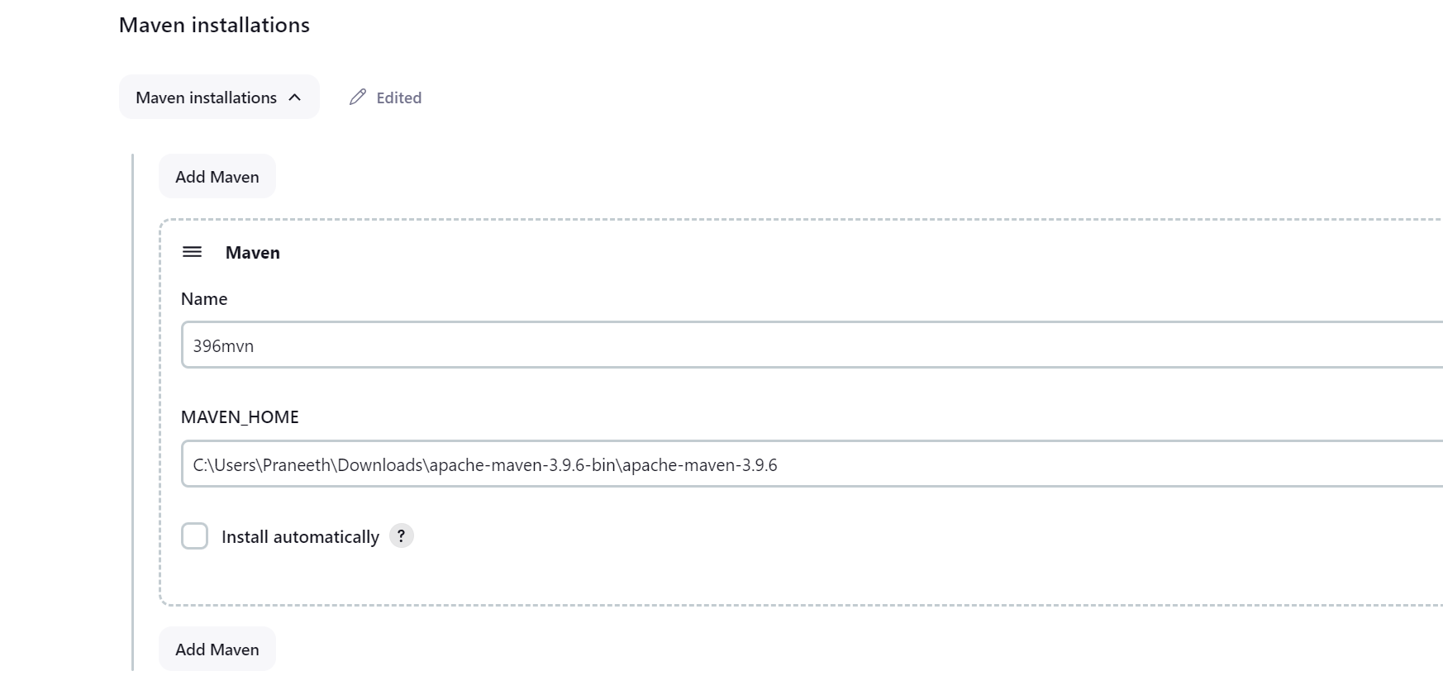

1. Run Build Now, it will show status

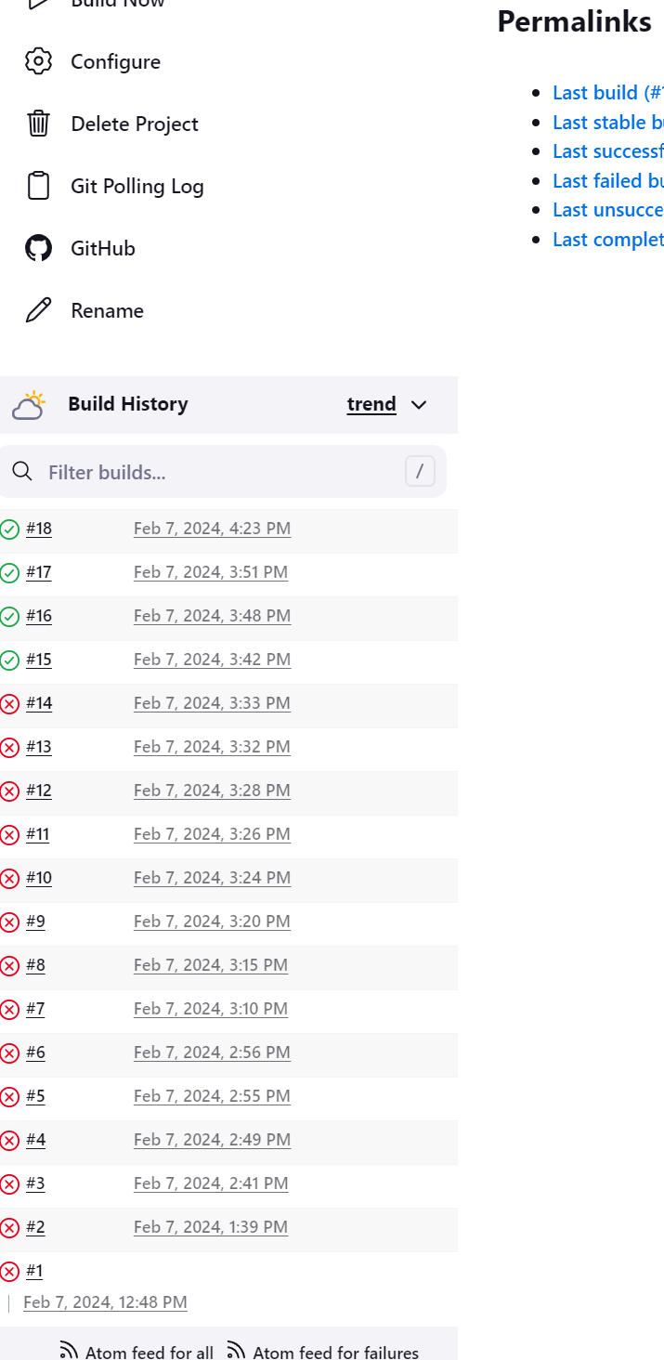

1. Check console output for status
2. Now whenever we commit new changes to our git, here based on time duration set, jenkins will trigger build and run, test, so that new changes are ready for deployment, if there is any error in build, it fails and will get mail.
3. Done with CI part.
4. CD part, we create a pipeline, in which first dev -> qa -> prod, in the respective order buils will be triggered.
5. We create 3 items or jobs. dev, uat and prod, remove the poll scm(build trigger duration) for uat and prod, as we want them to build only after dev job is done.

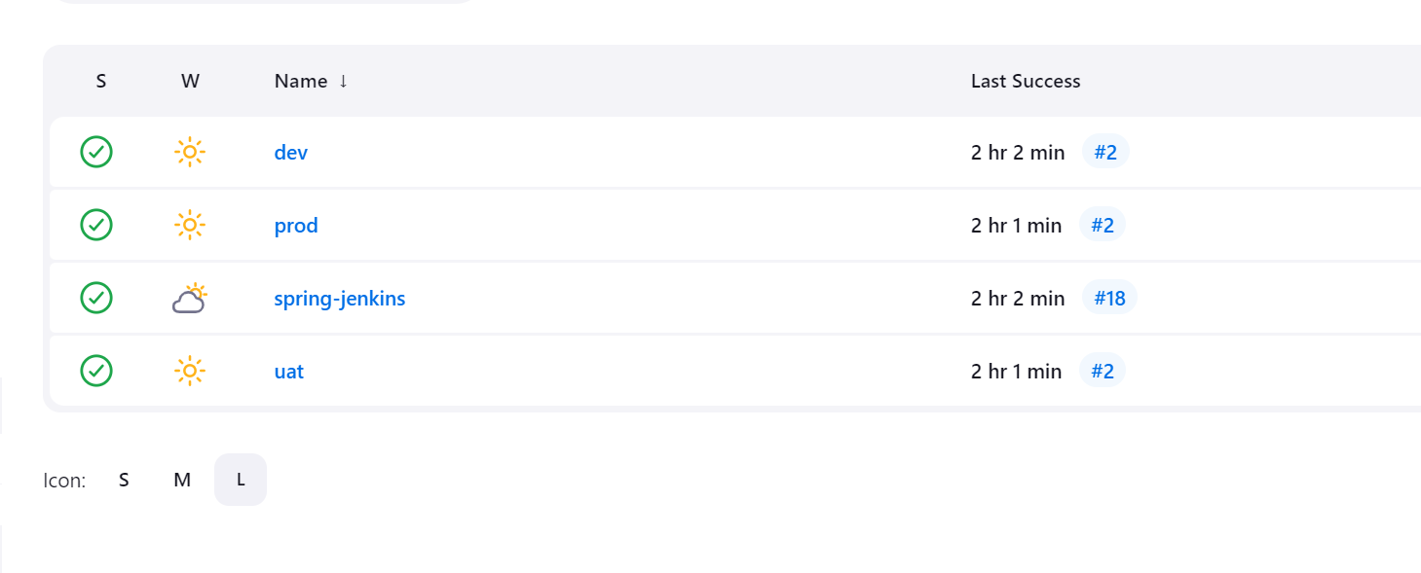

1. To create a pipeline, create a new view with option as Build pipeline view, if the option is missing have to add the Plugin with same name.

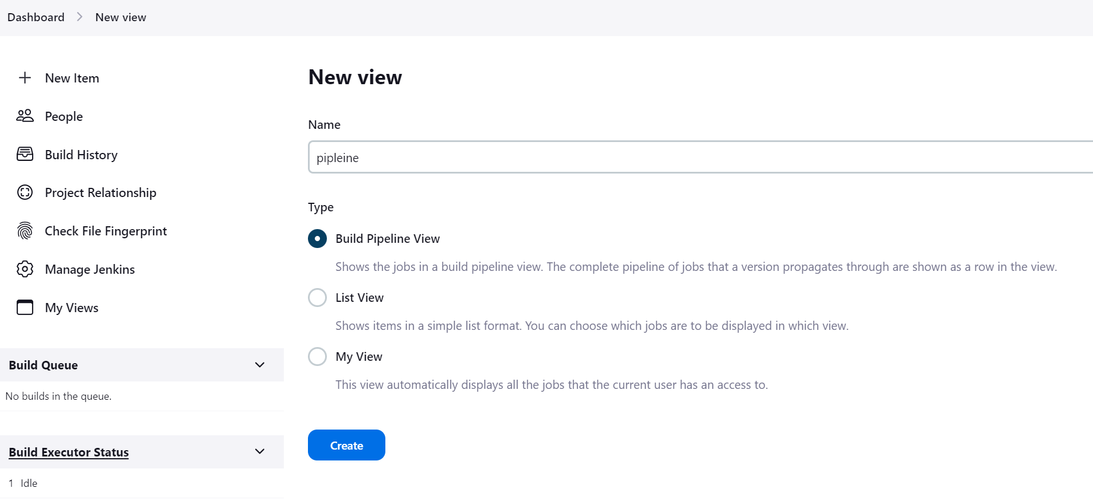

1. Select initial job in configuration, in our case we want dev first

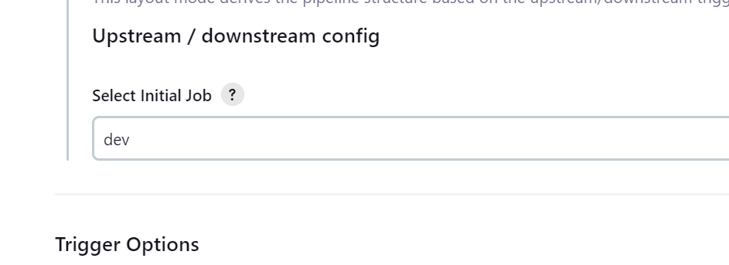

1. Now go to uat and prod jobs configuration, select option Build after other projects, for uat job enter dev, for prod job enter uat.

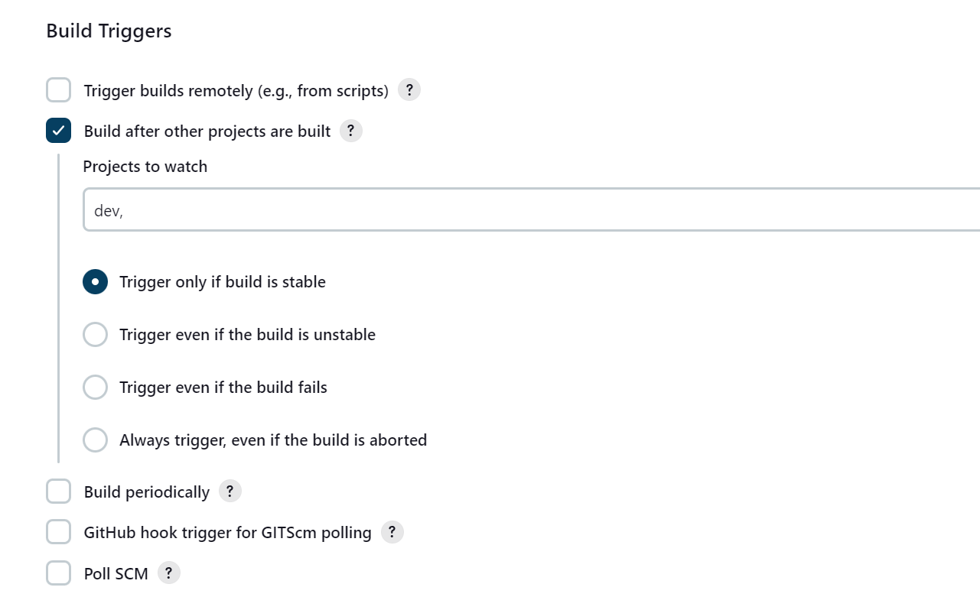

1. Now push any changes to code, so the dev job will be started, go to pipeline, we can see one by one jobs will be triggered

